Welcome to Young Living Essential Oils!

Hi new friend! I’m Chelsea Young, your team leader. I am so thrilled for you to start elevating your home & wellness with Young Living essential oils & oil-infused products! Let’s do this! To help you to get started, here are some quick tips:

1.) Plug into our Facebook group, Gettin’ to Livin’ Tribe!

This is our exclusive, main team group that is the best, free resource! It’s on Facebook, to join click here: bit.ly/joinG2L

What Gettin’ to Livin’ Tribe offers:
-a community of both brand new & seasoned Young Living members
-daily helpful tips on YL products & how to ditch toxic products
-info on our monthly subscription box promos aka Essential Rewards
-first insight on monthly promos, flash sales, & new product launches
-free online classes within the group & access to team graphics
-ability to ask any compliant question
-Tribe exclusive giveaways & contests and MORE!!!

Make sure you look at the pinned post and the links/videos. Leave your notifications turned on so you don’t miss an oily thing! To learn how you can get paid for referrals, ask to be added to our Gettin’ to Livin’ - Oil Biz group!

2.) Virtual Office Tour, aka how to navigate your Young Living account!

When you login to your Young Living account with your member # & password, that is considered your Virtual Office. Here you place your monthly subscription box order (Essential Rewards), view monthly promos, & so much more. There is a fantastic, quick, easy ‘Getting Started’ section that helps you to get to know Young Living, walks you through your first 7 days, gives you tips on sharing YL, & embracing the YL lifestyle!

Also - Grab your referral link! Click ‘Member Resources’ then ‘Link Builder’. Copy & paste this link & send to anyone that you talk to about oils. You’re then paid for your referrals! Wahoo!

3) Some extras to consider grabbing before your kit arrives:

-A reference guide (app - Ref Guide 4 EO or purchase a book at discoverlsp.com)
-An oil rack (etsy)
-An oil carry case (Young Living or etsy)
-Carrier oil (examples: V-6 - item #3031 or 3030, jojoba oil, coconut oil, almond oil, etc.)
-Vegetable capsules (250pk - item # 3193)
-Roller bottles (amazon or etsy) or AromaGlide Roller Fitments (10pk - item #4578)
-Amber glass or stainless steel spray bottle for Thieves Cleaner (amazon or etsy)
-Car diffuser (Young Living)

4) Do the 10-Day Starter Kit Challenge
Or text ‘Get Started’ to (585) 301-4478 to receive a daily text from me on how to use your PSK!
Happy Oiling, XO Chelsea Youn
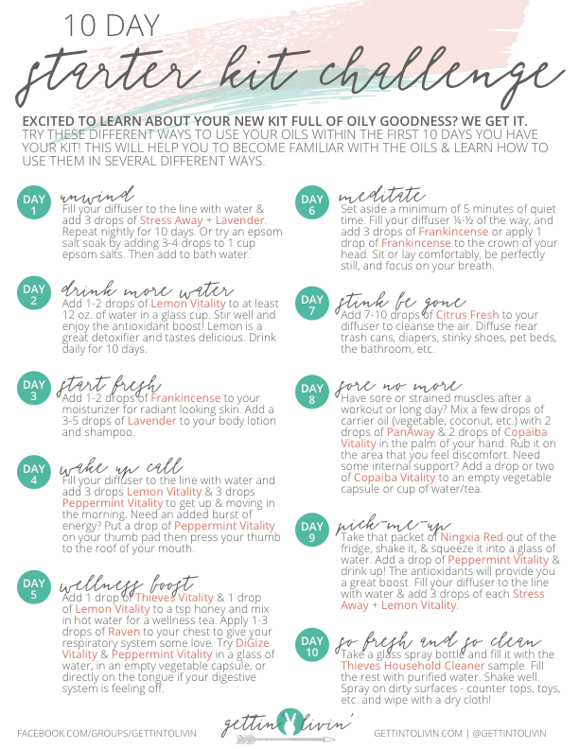
Type to enter a caption.

